Southern Arizona Development: Using Remote Sensing to Map the Change from Desert Landscape to Development

By Abigale Cole

# Abstract

The Tucson Arizona Metropolitan area includes 20 different towns and cities within a 1,987 square mile area, and nearly 1 million people (USA.com). The population growth between 2002 - 2016 has been around 4% (Census.gov). By using remote sensing we can see the amount of desert landscape that has been developed to accommodate this population growth. By undergoing an unsupervised classification and calculating a change matrix the results are that 14.72% of desert landscape has been developed on. This overdevelopment of desert landscaping has far outpaced population growth.

# 

# Table of Contents

**Abstract** **2**

**Table of Contents** **3**

**Introduction** **4**

**Methodology** **5**

**Results** **8**

**Conclusion** **9**

**References** **10**

# Introduction

Tucson Arizona is a fast growing urban area. With new development environmental issues are arising such as urban heat islands (Comrie, 2000) and the loss of habitat for many species such as lizards (Germaine, 2002). By understanding the implications of development we can better understand how to avoid the negative effect on the environment. The question that is posed is: is this new found growth warranted given the population growth in comparison to the amount of desert landscape loss. In this paper the comparison between land use of 2002 and 2016 is used to make the argument that developers and the city are over developing the Tucson area causing loss of desert landscape.

# Methodology

The study area is the Tucson Metro Area from Marana down to Green Valley while keeping the East border in the confines of Pima County. This area is home to approximately 1 million people. Davis Monthan Air Force Base and the University of Arizona call Tucson home. With other industries such as the medical field continuing to grow (ConnectTucson.com) development is necessary but how much is the question. The years for the comparison are 2002-2016 which Landsat images are used for (Landsat 7 for 2002 and Landsat 8 for 2016). Using ArcGIS Pro (Version 2.7.1) an unsupervised classification is done on both images. An unsupervised classification assigns pixels into categories of a similar type. The classification is sorted into 20 clusters (user chosen), then the ISODATA algorithm performs the classification making decisions based on distance between the multispectral vector for the pixels and multispectral mean for each class. These clusters are then divided into classes. The classes that will be used are; developed, desert landscape, forest, bareground and grass/ agricultural. These 5 classes cover most of the land cover/ land use for the study area. For this analysis the primary concerns are the developed and desert landscape categories.

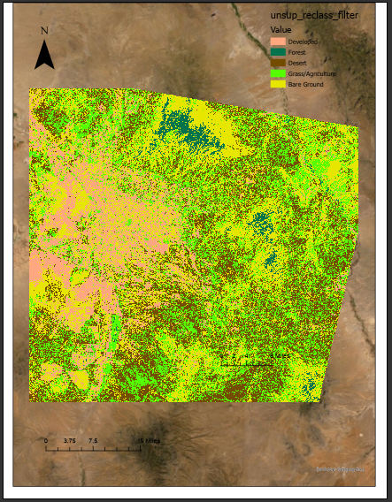

Figure 1: 2002 Landsat 7 Image Classified

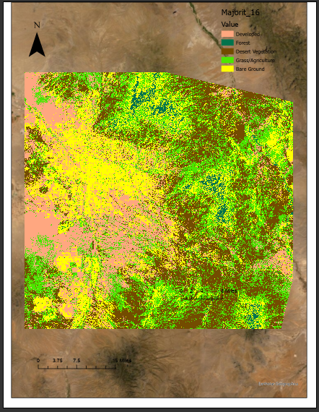

Figure 2: 2016 Landsat 8 Image Classified

# Results

After each Landsat image has been classified each cover type was identified for each class. After the images have been identified a reclass is performed to take the 20 classes down to our 5 cover types; developed, desert landscape, forest, bareground and grass/ agricultural (See figure 1 and 2). Once this is done for both images a combine is done so we can compare the rasters to one another (See Figure 3). By looking at the areas in which changed from desert vegetation to developed we can get an accurate picture of how much has changed in Southern Arizona.

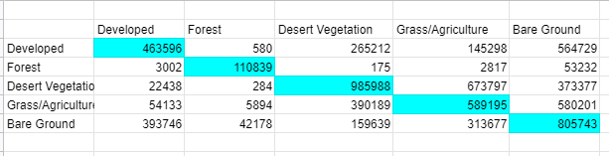

Figure 3: Change Matrix comparing 2002 (X Axis)-2016 (Y Axis) Landsat images

# Conclusion

Due to our analysis we see that 265,212 pixels of desert landscape have been developed on which is 14.72% of all desert landscape. With only a population growth of 4% we would expect that number to be much lower. With the analysis being completed Tucson is overdeveloping the desert landscape. With the loss of desert landscape there are many environmental impacts that need to be looked at and what conservation efforts need to be taken in order to lessen the impact. The next steps which need to be taken are focusing efforts on which areas that have been developed (or will be soon be) and cataloguing the native species that lost habitat. By further understanding this we can begin to provide environmental assistance to make sure these species will not be at risk for extinction.

# References

Comrie, Andrew C. " Mapping a Wind-Modified Urban Heat Island in Tucson, Arizona (with Comments on Integrating Research and Undergraduate Learning)", Bulletin of the American Meteorological Society 81, 10 (2000): 2417-2432, accessed May 8, 2021, <https://doi.org/10.1175/1520-0477(2000)081><2417:MAWMUH>2.3.CO;2

S.S. Germaine, B.F. Wakeling,

Lizard species distributions and habitat occupation along an urban gradient in Tucson, Arizona, USA, Biological Conservation, Volume 97, Issue 2, 2001, Pages 229-237, ISSN 0006-3207,

https://doi.org/10.1016/S0006-3207(00)00115-4.

“Tucson Metro Area Population and Races.” USA.com. Accessed May 7, 2021. <http://www.usa.com/tucson-az-area-population-and-races.htm>.

“Tucson Metro Area.” USA.com. Accessed May 7, 2021. http://www.usa.com/tucson-az-area.htm.

“US Census Bureau QuickFacts: Tucson city, Arizona”. Census.gov. Accessed May 7, 2021.<https://www.census.gov/quickfacts/fact/table/tucsoncityarizona/PST120219>

“Why Tucson”. ConnectTucson.com Accessed May 7, 2021. <https://connecttucson.com/why-tucson/>

ArcGIS Pro (Version 2.7.1). Esri Inc. https://www.esri.com/en-us/arcgis/products/arcgis-pro/overview.